**ASSIGNMENT 4.5**

**on**

**Cloud Deployment**

**Submitted by:**

**Haseebullah Shaikh (2303.KHI.DEG.015)**

**and**

**Faiza Gulzar Ahmed (2303.khi.deg.001)**

**Dated:** 16th May 2023

**Solution:**

1. **Created AWS Cluster to get necessary resources such as VPC and subnets.**

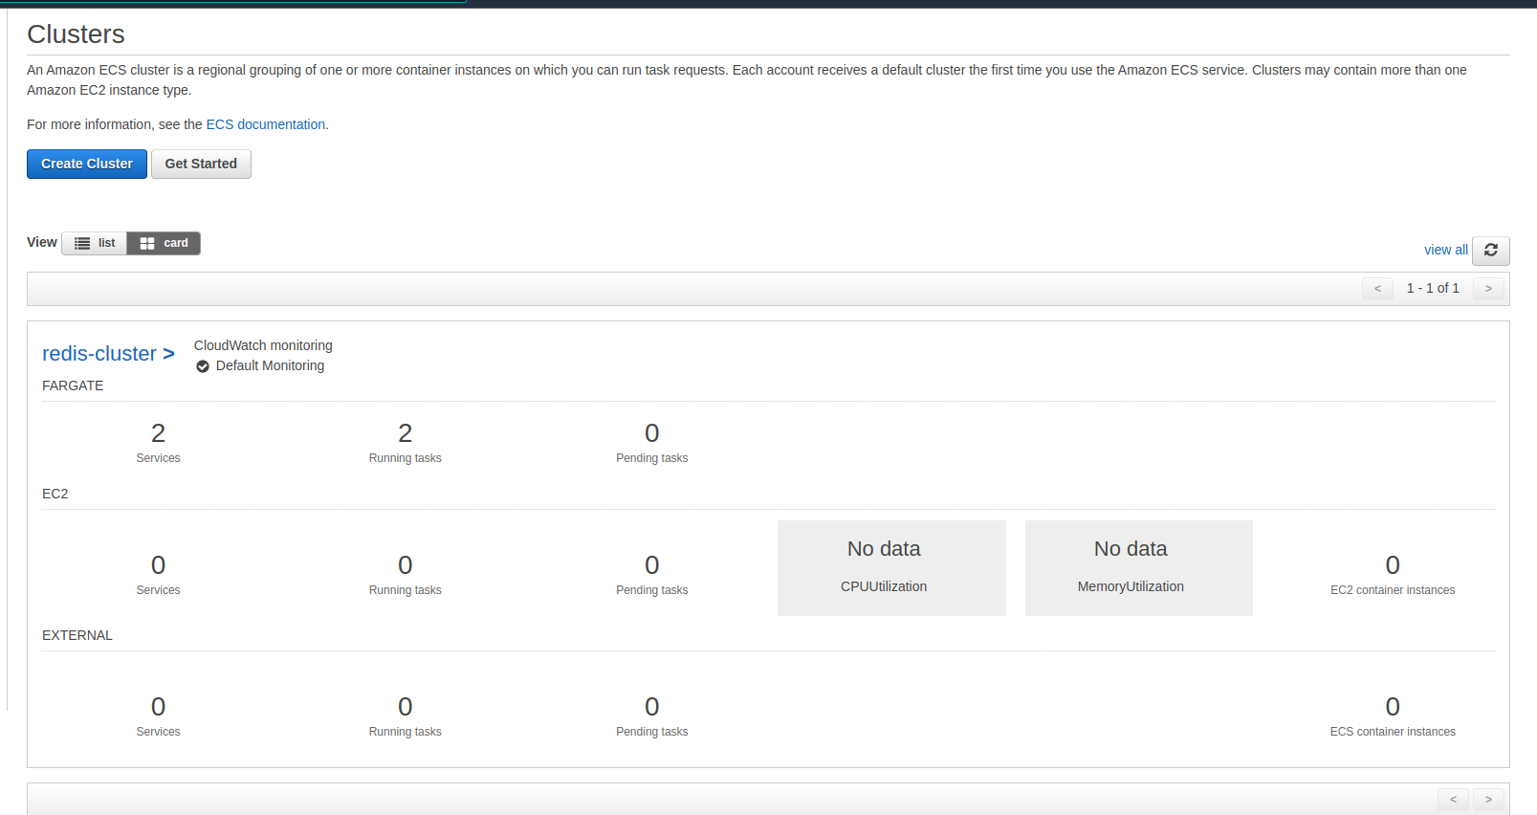

1. **Setting up service recovery to enable commination between redis and counter app using same vpc.**

Creating name space

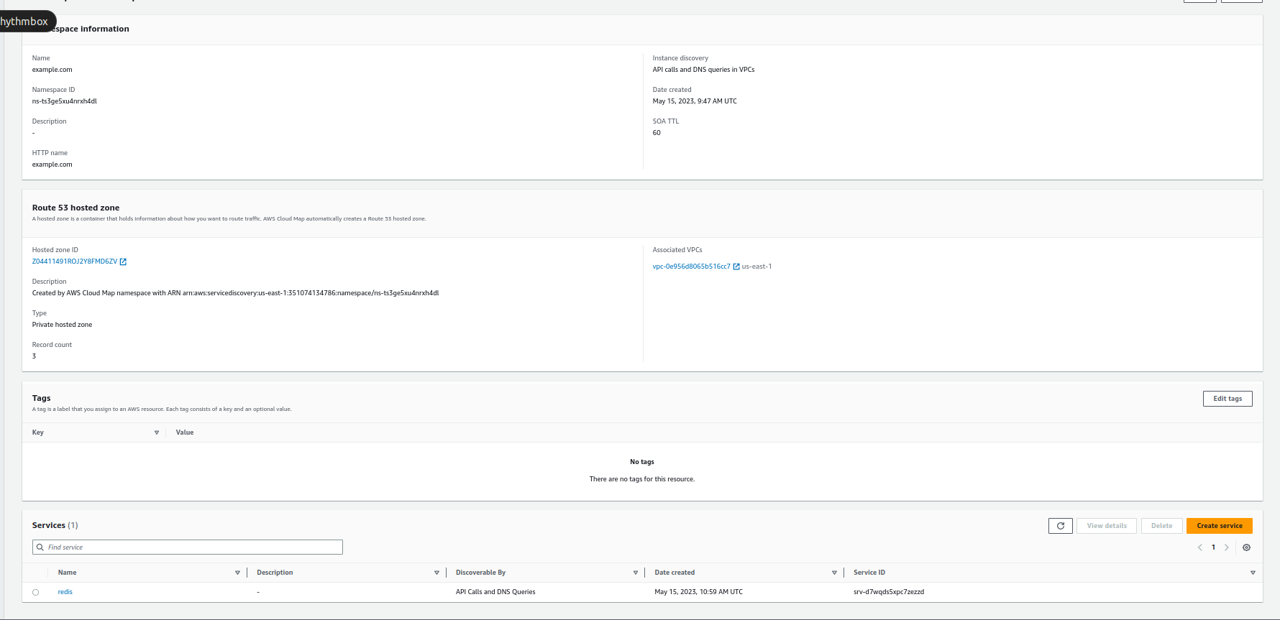

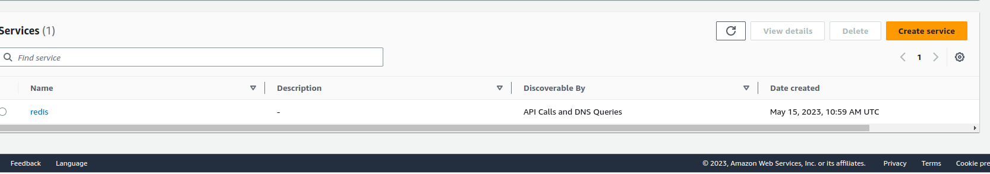Creating Service in the namespace

**3. Built and pushed docker images to Amazon Container Registry**

Created two private repositories redis and app.

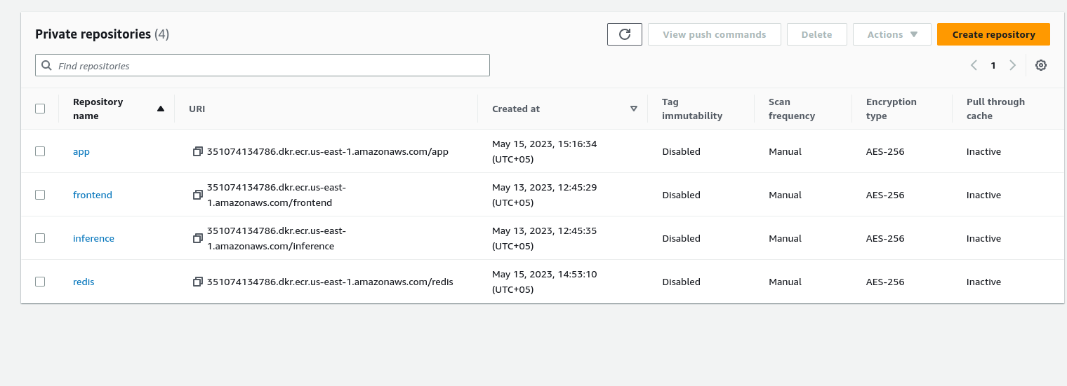

Pushed the images in their respective repository using commands in view push commands.

Pulled and pushed redis image

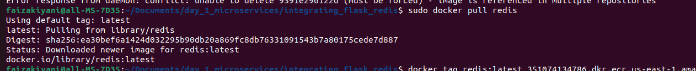

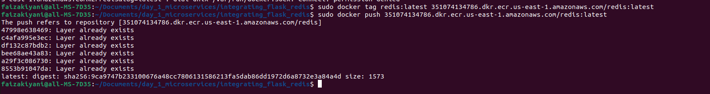

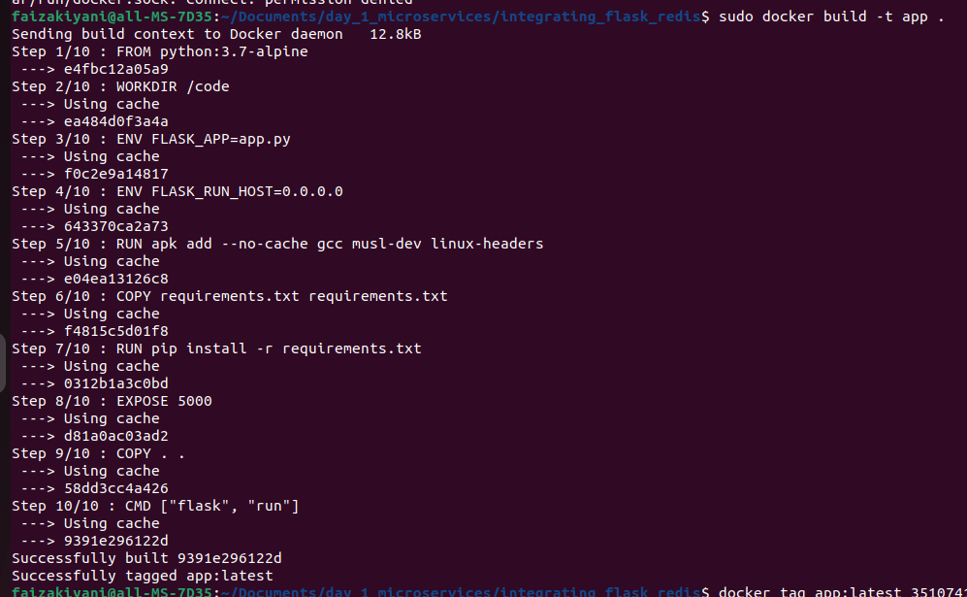Built and pushed app image

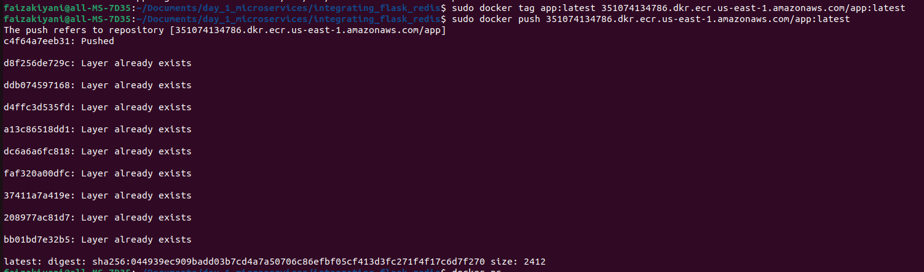

**4. Created task definition for each service specified provided memory and cpu, created container for each service to add image. Assigned appropriate ports and enviroment variables.**

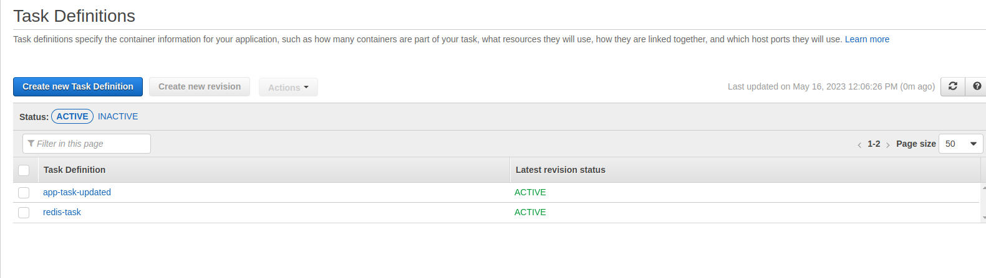

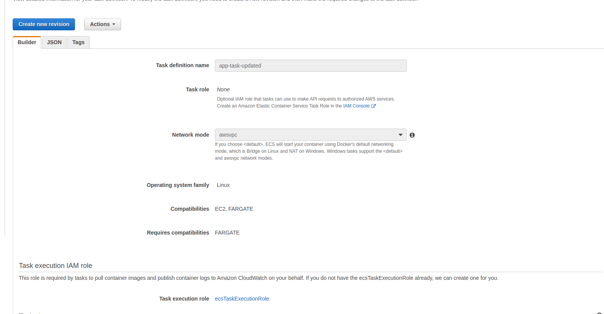

Setting the enviroment variables REDIS_HOST and REDIS_PORT, that we have updated in existing given app.

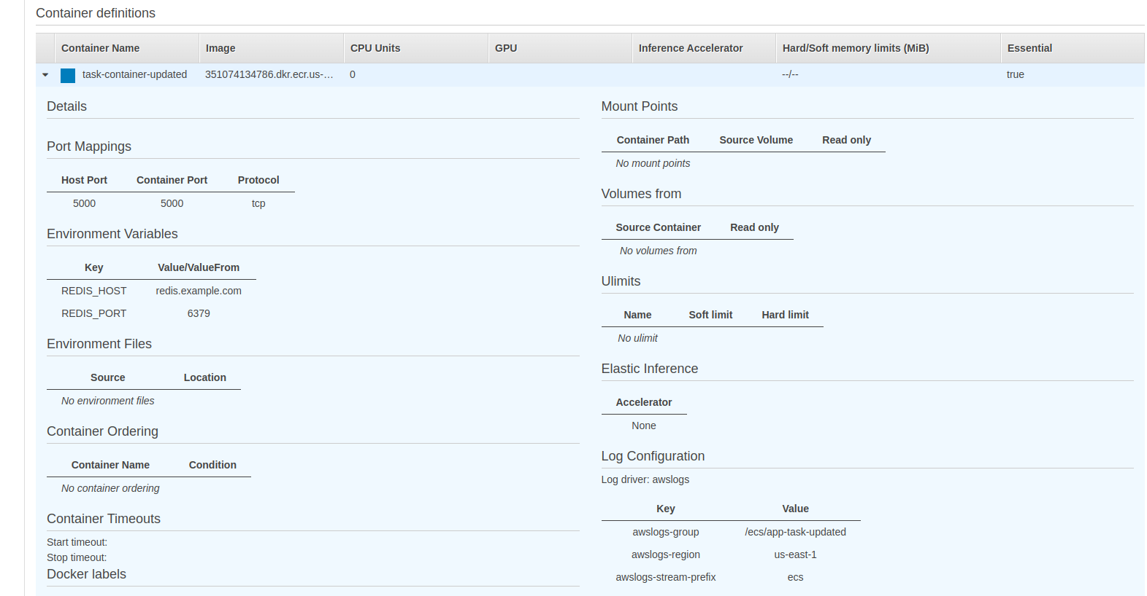

Updated app for creating enviroment variables, so app service can access the redis through these enviroment variables.

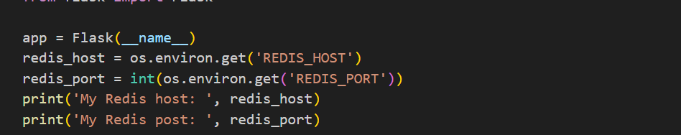

Creating task for redis service adding container for image and setting appropriate port**.**

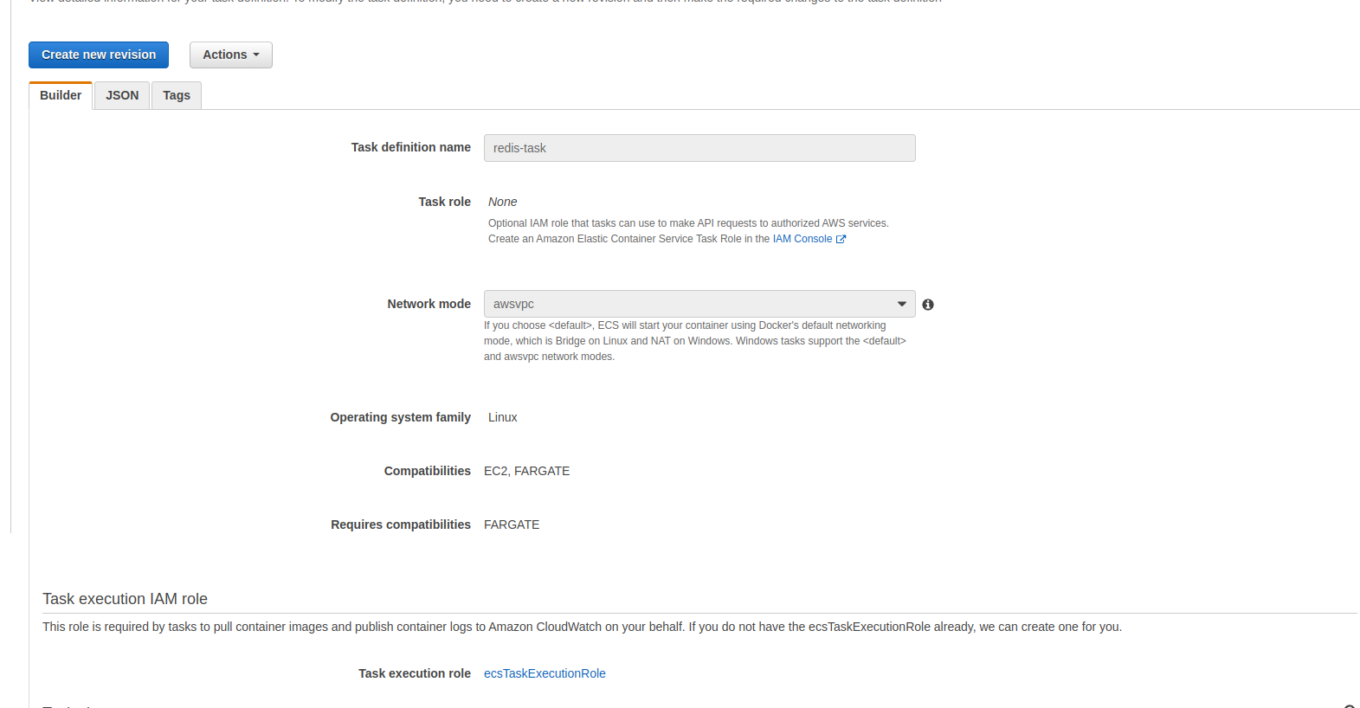

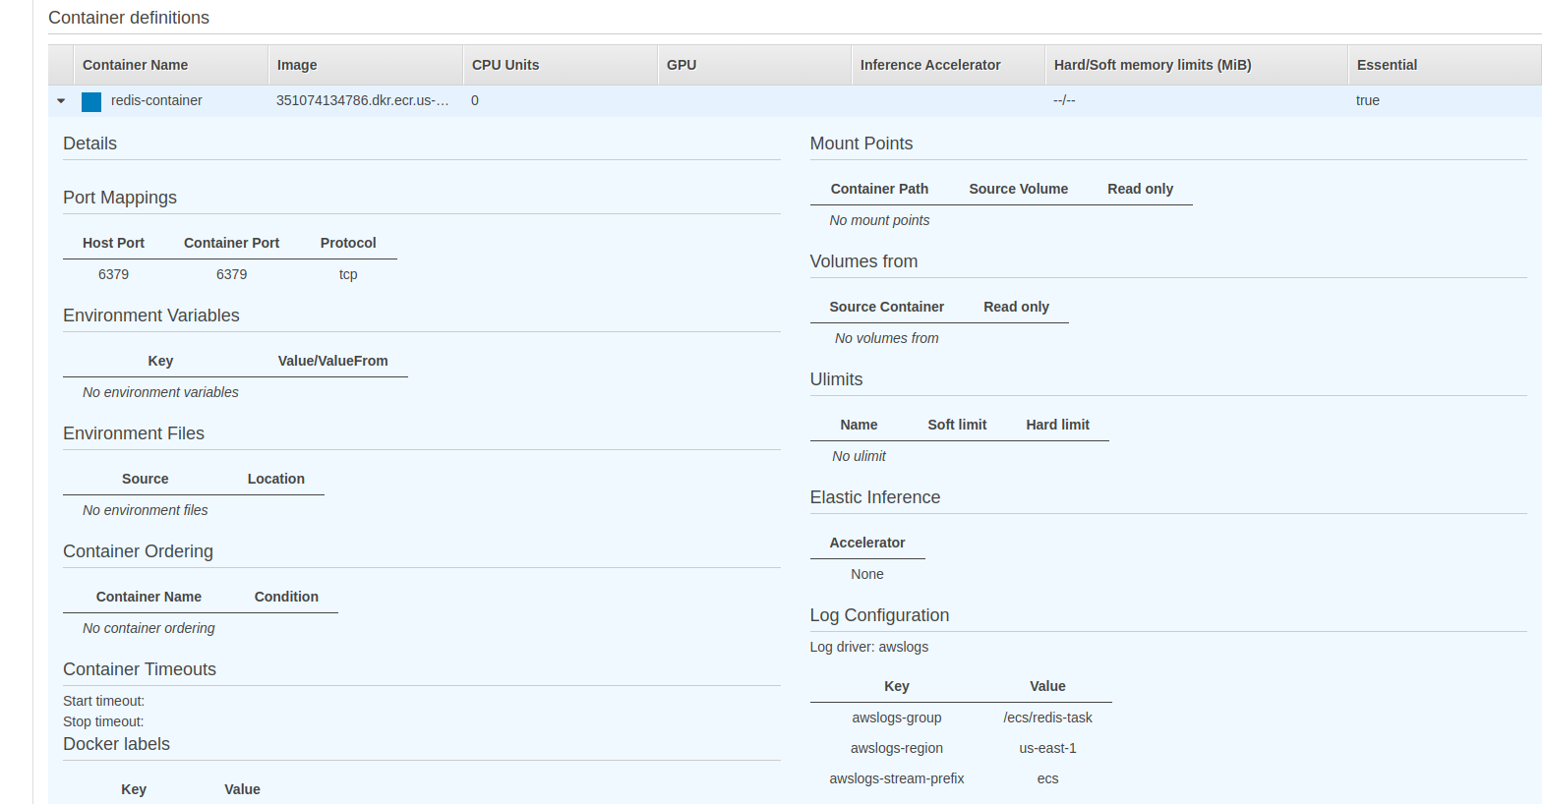

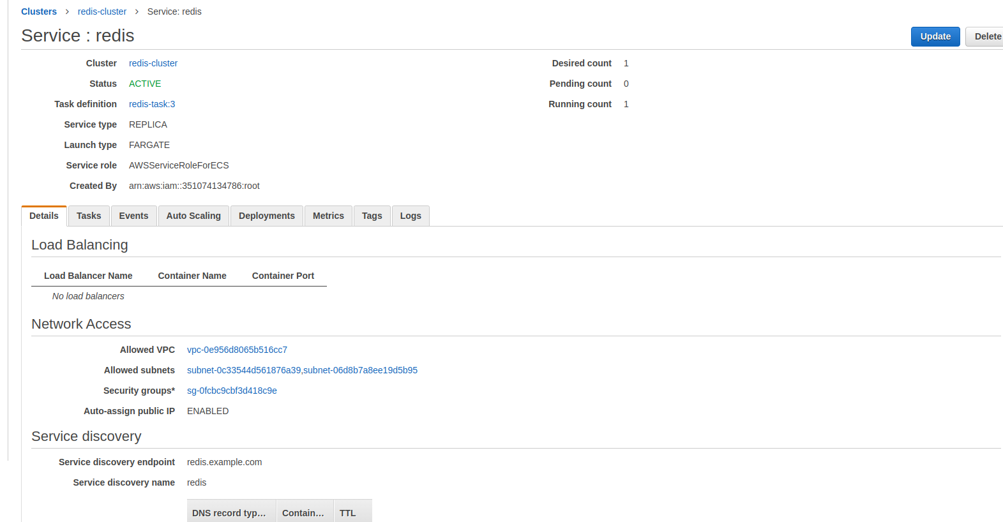**5. Created two ECS services redis and app in previously created cluster.**

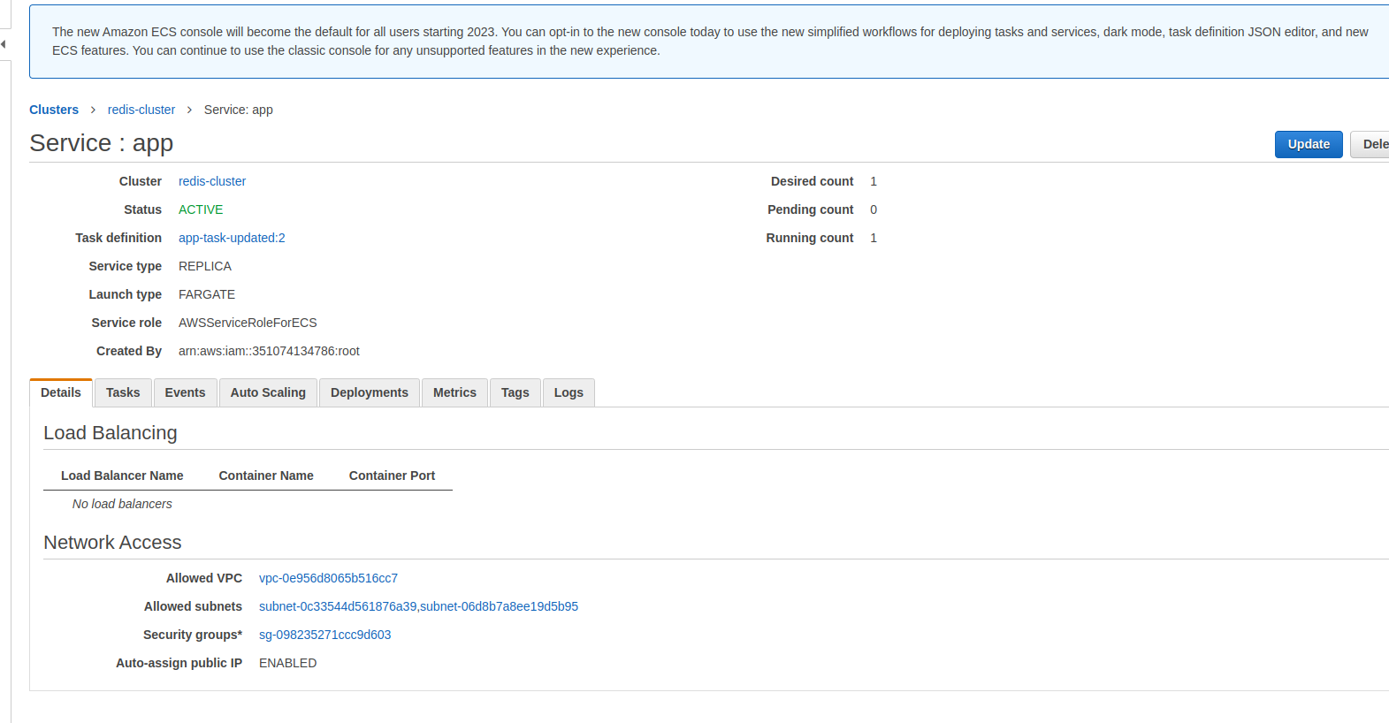

**Verifying app is accessible at port 5000 and can communicate with redis for storing visits counts in cache.**

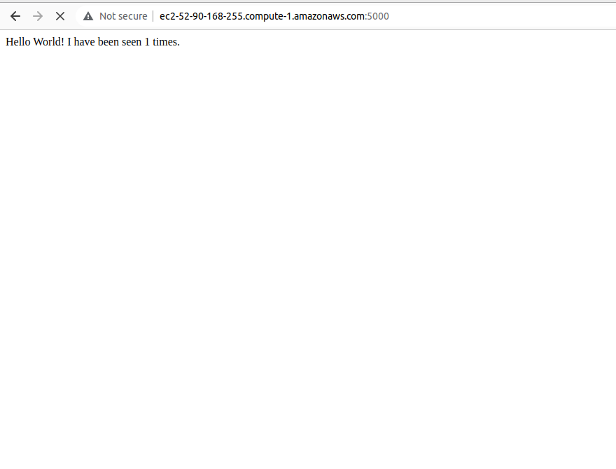

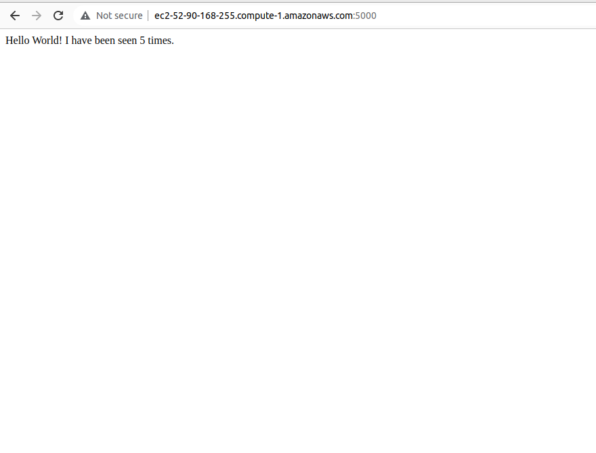

**The End ☺**